Mortality events are important drivers of Bering Sea crab populations
Cody Szuwalski^{1,2} other authors to come
¹National Oceanic and Atmospheric Administration, Alaska Fisheries Science Center, Seattle, W
²University of Washington, School of Aquatic and Fishery Sciences, Seattle, WA

Abstract
Crab are some of the most abundant species in the Bering Sea and support fisheries historically valued at over $300 million ex-vessel per year. Boom and bust dynamics are common and have produced fisheries closures for several stocks. We use population dynamics models to identify drivers of change for six crab populations in the Bering Sea. Most population-wide declines appear unrelated to crab fisheries, but fisheries have large impacts on the small fraction of the population harvested. Recruitment variability and episodic mortality are key drivers of change; density-dependence, ice, size, and temperature explain a significant portion of the variability in mortality for Bering Sea crab. Incorporating variable mortality into management projections lowers expected yields and biomasses. Our results underscore the need to model historical and future mortality events in fisheries management and to attempt to understand their drivers, in spite of the complications to traditional management strategies it can present.

Body
Crab are some of the most abundant species in the Bering Sea ecosystem and historically have supported some of the most valuable fisheries in the Bering Sea (together with salmon and pollock). In particular, snow crab and Bristol Bay red king crab have supported large and valuable fisheries, but several other more lightly fished populations also exist in the Bering Sea (figure 1). The trajectories for most of these populations are volatile; booms and busts are common. Most recently, the snow crab population collapsed to unprecedented levels after a marine heatwave in 2018-2019 (1) and the fishery was closed for the first time ever. This coincided with a closure of Bristol Bay red king crab, which put communities dependent upon crab fisheries under considerable financial strain and precipitated a ~$150 million disaster relief effort (2). Large variability in crab abundance occurs in spite of intense management and some of the best data in the world (3). Population surveys for Bering Sea crab exist stretching back to 1975 (4), catch data from the fisheries are carefully collected both on the docks and at sea (5), and laboratory experiments are routinely conducted to understand population processes like growth and maturity (6,7).
Management for Bering Sea crab is similar to most other closely managed fisheries with extensive data. Each year acceptable biological catches are set based on three outputs from a stock assessment: current biomass, target biomass, and a target fishing mortality. Colloquially, these pieces represent ‘where we are, where we want to be, and how we get there’ (respectively). Targets for biomass are based on equilibrium projections that assume stationarity in recruitment (i.e. young crab entering the population) and a constant natural mortality. However, periods of elevated natural mortality have been required to fit the survey data for crab in the assessments used in management, suggesting natural mortality is not constant. Furthermore, there is a possibility of unobserved mortality in groundfish fisheries of unknown magnitude as a result of trawl gear fatally impacting, but not capturing, crab on the sea floor (8).
Given the observed boom and bust dynamics and a potential violation of assumptions made in management, we ask the following questions: 1) how frequent are large declines in Bering Sea crab populations, 2) what drives these declines and are there common linkages, and 3) if population collapse is a common phenomenon, how can this information be used in management?
To answer these questions, we fit population dynamics models to the available data for crab populations in the eastern Bering Sea that incorporate a key difference from the stock assessment models used in management: the estimation of an annually varying ‘other mortality’ that accounts for processes like predation, unobserved mortality in non-directed fisheries, cannibalism, disease, and starvation. We then used generalized additive models (GAMs; 9) to explain variability in our estimates of other mortality using population abundance, ice cover, temperature occupied, and average size as covariates. We identified periods during which a population declined more than 40% and used our model estimates to identify drivers for each of these population declines. Finally, we explored the impacts of incorporating the expectation of mortality events into management. Based on these analyses, we end with suggestions for managing Bering Sea crab fisheries and for the larger natural resource management community in general.
We modeled six populations: snow crab, Bristol Bay red king crab (BBRKC), Tanner crab, Pribilof Islands red king crab (PIRKC), Pribilof Islands blue king crab (PIBKC), and Saint Matthews blue king crab (SMBKC). The models fit the available data well with acceptable diagnostics for all populations (see SI). Large correlations existed among estimated population processes among populations, which suggests shared drivers of dynamics. For example, Tanner crab, immature snow crab, and PIRKC all had significantly-correlated estimates of other mortality, as did the two populations around the Pribilof Islands (figures S1-4). Other mortality for mature snow crab and BBRKC, the two most valuable commercial populations, were also significantly positively correlated. Abundance trajectories were positively correlated for the blue king crab stocks and BBRKC, reflecting coincident large declines seen in these populations.
GAMs incorporating abundance, average size, ice cover, and temperature occupied explained the variability in estimates of other mortality significantly better than not including the variables for all population/maturity combinations (figure 2). Higher abundances were associated with higher mortality for all populations except Tanner crab and SMBKC (figure 2). Larger average size was associated with higher mortality for all populations except BBRKC, which had U-shaped relationships. Ice extent was one of the most important variables for predicting variability and higher mortality was associated with less ice for all stocks except blue king crab. Temperature effects were confounded with ice for some stocks, but higher temperatures were often associated with higher estimated mortality (see SI for discussion).
The combined contributions of changes in recruitment, fishing mortality, and other mortality produced volatile total abundance trajectories for Bering Sea crab (figure 3). Abundance declines of 40% or greater happened 20 times across all populations in the past ~50 years, but only 4 of these were associated with estimated fishing mortalities higher than the median estimated rates. This, coupled with the relatively small fraction of the population vulnerable to fishing (figure 4), suggests crab fishing is rarely a large driver of population-wide decline other than for blue king crab, primarily because much of the population is protected by the size-selective nature of the fishing. Nonetheless, fishing can (and does) have large impacts on the small fraction of the population that is vulnerable to the fishery, which in turn can have large implications for the economic stability of the fisheries, particularly if there are feedbacks within the population between growth, maturity, and density (as in snow crab, 10).
Even when estimated fishing mortality is high, caution must be taken when using it as an indicator of fishery-driven decline. For example, the decline in snow crab abundance after the 2018-2019 heatwave was primarily driven by declines in the proportion of the population not vulnerable to the fishery; <1% of the population was large enough to be retained in the fishery (figure 4). So, even though estimated fishing mortality was high, it was clearly not the driver of the population-wide collapse. The remaining large drops in abundance for Bering Sea crab were related to increased mortality, low recruitment, or a combination of the two. Clusters of population declines occurred during three periods: 1980-1984, 1996-1999, and 2015-2020. These all marked periods of ecosystem change and/or were relatively warm (11).
The output of our models allows us to begin to develop ecological histories for each population. For example, snow crab has gone through two periods of boom and bust. The largest population abundances occurred during 1990s, but the population declined sharply in 1999. Neither fishing mortality nor other mortality were above average during this period: the declines were driven by a sustained collapse in recruitment. The management response was strong--the population was declared ‘overfished’ (which, in spite of referencing ‘fishing’, is a term used to describe a stock that is at low relative abundance regardless of cause in U.S. fisheries; 12) and the stock slowly rebuilt. In the mid-2010s, the largest recruitment event observed in the population occurred and the population was projected to increase to abundances not seen since the 1990s. However, the population collapsed again before those projections could come to fruition and this collapse was the result of a mortality event, not a recruitment failure. A model similar to those used within this manuscript was developed for snow crab to try to understand what drove the mortality behind the collapse. Predation, cannibalism, temperature, disease, non-directed fishery bycatch, and density-dependent effects were considered as potential drivers. Ultimately, the model output suggested that the 2018-2019 marine heatwave increased the metabolic requirements for snow crab and that starvation likely contributed to the collapse (1). This modeling result was later corroborated by laboratory and field studies (13, 14).
Ecological histories are only possible when using models that estimate a time-varying ‘other mortality’ (see SI for more stock-specific histories). Developing appropriate indices to evaluate drivers of population change as was done for snow crab is time- and resource-intensive and depends on continued funding for surveys and laboratory studies. We argue that this sort of history-building will be increasingly important to management, so that population changes for which management has a ‘lever’ to enact change (e.g. directed fishing) can be distinguished from those management does not (e.g. climate change) or those only infrequently considered (e.g. predation or disease). Dangers also exist in building ‘just-so-stories’ around ecological models. Determining causality from observational data can be difficult, particularly in complex systems with relatively short time series (15). Nonetheless, there are considerable risks in not attempting to understand the population changes in a broader context than just fishery-driven dynamics. Assuming that population dynamics are driven by fishing when they are actually driven by climate or disease (for example) can result in misdirected (and ultimately wasted) management resources. Experiments, surveys, and analyses aimed at identifying drivers of population changes are likely the best hope for designing effective management strategies as climate change reorganizes ecosystems.
Regardless of the true underlying drivers of population change for Bering Sea crab, Bering Sea crab populations are in crisis. The median estimate of commercial abundance during 2023 across all populations was less than 5% of the maximum observed, with the two most economically important populations (BBRKC and snow crab) estimated at 1.7% and 7.2% of maximum, respectively (figure 4). Given the currently poor status of Bering Sea crab populations, it is natural to ask if incorporating the expectation of episodic mortality events into biomass and fishing mortality targets could improve management outcomes for Bering Sea crab. To explore this question, we parameterized a model based on BBRKC and then calculated equilibrium management targets and expected yields in two ways. In the first set of projections, other mortality was assumed to be constant. In the second set, we sampled yearly other mortality from historical estimates and simulated 1000 populations to develop a distribution for the expected yield and biomass for a given fishing mortality under the possibility of episodic mortality events.
Expected yield and biomass were nearly halved when allowing for the possibility of mortality events and variability in yield and biomass was high (figure 4). Depending on the timing and magnitude of mortality events and their relationship to the timing of recruitment events, biomasses could range from 5-200% of the equilibrium value. Even though there were large differences in expected yields and biomass, the fishing mortality that produced the maximum long-term yield did not change. The key change to the harvest control rule produced by incorporating expected mortality events would lower the target biomass. This would allow fishing to occur at much lower abundances than is currently allowed. Unintended consequences of incorporating environmentally-driven variability into management targets (i.e. increasing the fishing pressure on populations undergoing ‘stress’) happen for other population processes as well. For example, incorporating climate change effects into recruitment for snow crab would result in lowering biomass targets as ice recedes, allowing higher exploitation rates to occur as the population is undergoing climate stress (17).
The current management goals for Bering Sea crab are to provide ‘optimal yield’ based on the equilibrium concepts of maximum sustainable yield (12). Firmly negative population trends culminating in all-time lows of commercial biomass for many populations in the last decade suggest that management may not be achieving those goals, in spite of what appear to be relatively conservative harvests. Multiple violated assumptions of the underlying theory behind status quo management strategies suggest that working backwards from what has occurred rather than what ‘ought’ to have occurred based on theory might yield more positive results. In practice, this could mean taking a more experimental approach to exploitation rates to identify management actions that might improve stock trajectories (e.g. 18). Experimental management would likely need to be coupled with institutional change to provide fishers and communities dependent on crab fisheries more flexibility to support their livelihoods from the Bering Sea ecosystem.
Our observations and modeling for Bering Sea crab may have important implications for other managed living resources. Mortality events can occur for a range species for a range of reasons (19, 20) and management response might change for each. Broadly, resource management operates at two levels: strategic (i.e. goal setting) and tactical (i.e. actions to accomplish goals).
From a strategic perspective, protecting populations from (and after) collapse and supporting resource-dependent communities are often central goals and should guide the type of management actions considered. Protecting populations from/after collapse can be challenging in the current equilibrium management paradigm if adverse drivers are built into the calculation of expectations of the population under no fishing (as discussed above). The challenge arises from decreasing biomass targets asociated with incorporating expected collapses into the projection; this would allow for harder fishing at lower abundances compared to current harvest control rules. It is possible that alternate forms of harvest control rules could provide better management outcomes when populations are prone to mortality events. The shape of these rules would likely depend on the drivers of mortality events. Based on our analyses, consideration of population abundance, size composition, and environmental covariates may be useful.
The problem of boom-bust dynamics is not new; forage fish are the classic example in fisheries. Anchovy (Engraulis mordax) and sardine (Sardinops sagax) off southern California have gone through boom-bust cycles over the last 500 years (during much of which fishing did not occur) according to scales collected in the sediment around the Channel Islands (21). Crustacean populations can also vary considerably and withstand high fishing mortalities. For example, Dungeness crab (Metacarcinus magister) populations in the Pacific Northwest have persisted in spite of very high exploitation rates (>90% in some areas) on the large males (22). These examples suggest that fishing is not a dominant driver of population change for some species and might suggest a higher tolerance for low abundances when specifying allowable harvests.
However, a key difference between forage fish, Dungeness crab, and the Bering Sea crab in our study is life span and maturity schedule. Anchovies live 7 years and mature at 1-2 years old (23), sardines can live 25 years, but mature at 1-3 years old (24), and Dungeness crab live ~10 years and mature at 2-3 years old (25). In contrast, snow crab live up to 20 years and mature at ~6-8 years old (26), red king crab live up to 30 years and mature at ~5-6 years old (27), and blue king crab live ~20-30 years and mature at ~5-6 years old (28). These differences in life history, particularly the longer times to maturity, can be important for how responsive a population can be to favorable environmental conditions. These differences also might be related to why PIBKC has not recovered in spite of not being fished for a quarter of a century and why king crab populations in the Gulf of Alaska collapsed and have not returned (29).
From a tactical perspective, models with time-varying other mortality are not often used in fisheries science. The rationales behind a time-invariant mortality are reasonable if fishing is a primary driver of dynamics in a stationary system. First, changes in other processes alias for changes in mortality—a change in growth or catchability can look similar to a change in mortality (30, 31). Furthermore, the data to which population dynamics models are fit are also subject to observation error, so there is some risk that estimates of mortality are reflecting noise in the data rather than a signal from the population (32). In addition to difficulties reliably estimating variable mortality, small changes in the mortality rate used to calculate reference points can result in large changes to management advice (33). Because of these points, the prevailing advice for population dynamics models is to estimate a time-invariant natural mortality (34), often informed by a prior that considers the longevity of the modeled species (35).

Our modeling choices are a departure from current ‘best practices’ in stock assessment, but we argue that modeling ‘other mortality’ and attributing that mortality to some source(s) (or at least attempting to) will likely be an increasingly important issue as climate change progresses and when fishing may not be the primary driver of dynamics. The ability of a model to estimate mortality depends on how well other confounded population processes are known. For crab, simulations have shown that other mortality is estimable in circumstances of data availability and population dynamics structure like that in the Bering Sea (1, 36). Estimating other mortality may be more difficult for fish species than for crab given that variable catchability can be a larger problem for species than can swim over the top of survey trawls. With this in mind, we recommend that scientists and managers build models that have alternate assumptions about the drivers of dynamics (including time-varying mortality) and simulation test all population dynamics models, methods of attribution, and management strategies to understand their ability to estimate quantities need to make management decisions.
Collapses of harvested natural resources will continue to happen; predicting when and understanding why a population collapses is a hard, but important scientific problem. If causes of collapse can be identified, developing appropriate management strategies to avoid them can be relatively straightforward. For example, if predation is a key driver of a harvested population, incentivizing fishing for the predator in areas where there is the most overlap between predator and prey may reduce pressure on the prey population. If disease is a key driver of declines, effort spent identifying and minimizing vectors of transmission could help avoid collapses. Regardless of whether we understand the causes, management systems need the flexibility to promptly address sudden collapses, which may be more frequent as climate changes (37). These systems should be built on the principles that collapses should be met with decisive management action (e.g. closures and measures aimed at the underlying cause) and implementing social institutions that soften the economic blow to those dependent upon the resource (e.g. diverse fishing opportunities and incentivizing cooperative insurance).

Acknowledgements to come
Github.com/szuwalski/ebs_crab
References to come
- Szuwalski et al. 2023. Collapse of snow crab. Science
- Disaster relief
- Hilborn et al. 2021. Effective fisheries management. PNAS
- Zacher, L. 2025. Tech memo.
- ADFG observer data reference
- Richar,
- Long.
- Rose unobserved mortality work
- Wood. 2011. GAMS
- Szuwalski et al., density dependence can modulate climate effects.
- Hot Bering Sea during mortality events
- Crab FMPB
- Fedewa (body condition)
- Copeman (starvation study)
- Just so stories in ecology can blowup
- Causality hard
- Szuwalski, C .S. Unintended consequences.
- Walters experimental management
- Species collapse 1
- Species collapse 2
- Mclatchie 2017 sardine collapses
- Richarson, 2017 Dungeness crab in PNW
- Baxter, J.L., 1967. Summary of biological information on the northern anchovy Engraulis mordax Girard. CalCOFI Rep. 1:110-116.
- sardine life history
- Dungeness life history
- Snow crab life history
- Red king crab life history
- Blue king crab life history
- Gulf king crab collapse and no return
- Taylor ‘hide or die’
- Szuwalski, C.S. et al 2019 retrospective patterns
- Noise vs. signal in estimating mortality variation
- Thorson, JT et al. 2015. Mortality and reference points.
- Johnson KJ 2014. Default for time-varying M
- Hamel, O 2015. Priors for M
- Cronin-Fine, L. 2021; Sims for variation in M
- Litzow, MJ 2024. Borealization.
- Dew. Shifty regime.
- Litzow. Ocean acidification and BBRKC
- Long PIRKC PIBKC
- LONG PIRKC PIBKC

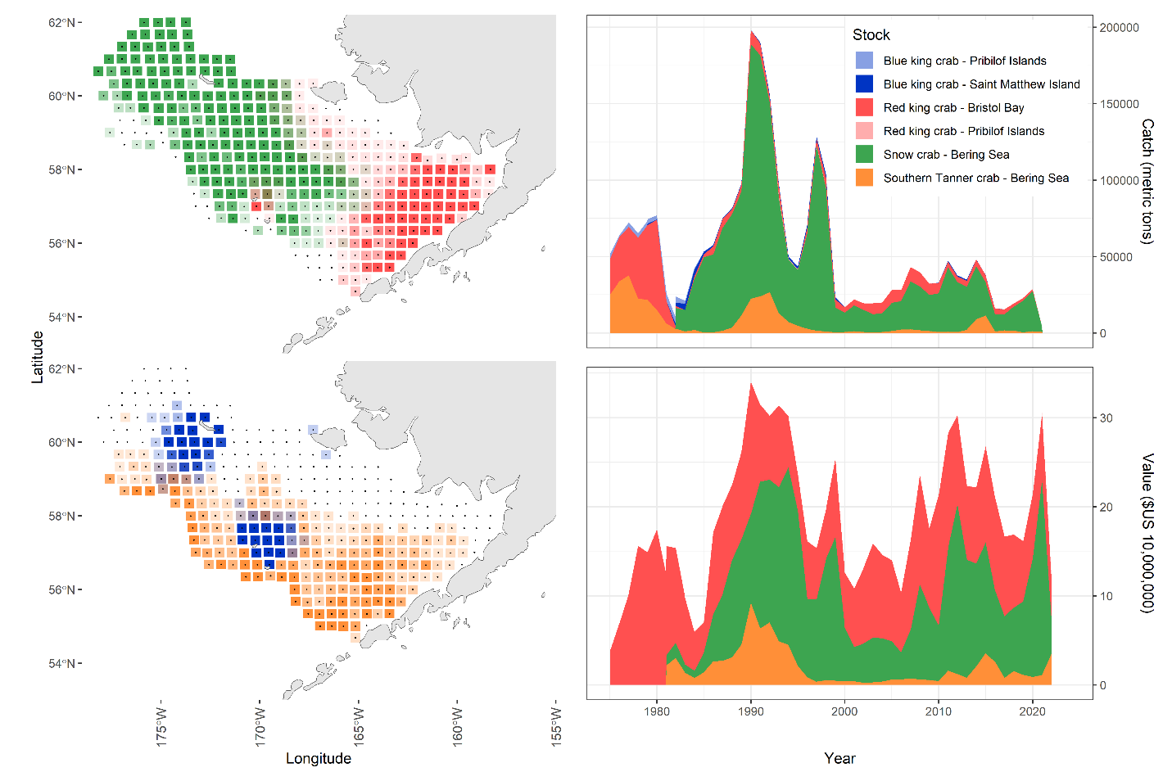
Figure 1. Distributions of crab populations in the Bering Sea (left) and the catch and ex-vessel value of that catch for crab populations (right). The upper blue king crab population distribution surrounds Saint Matthew’s Island; the bottom blue king crab population surrounds the Pribilof Islands.

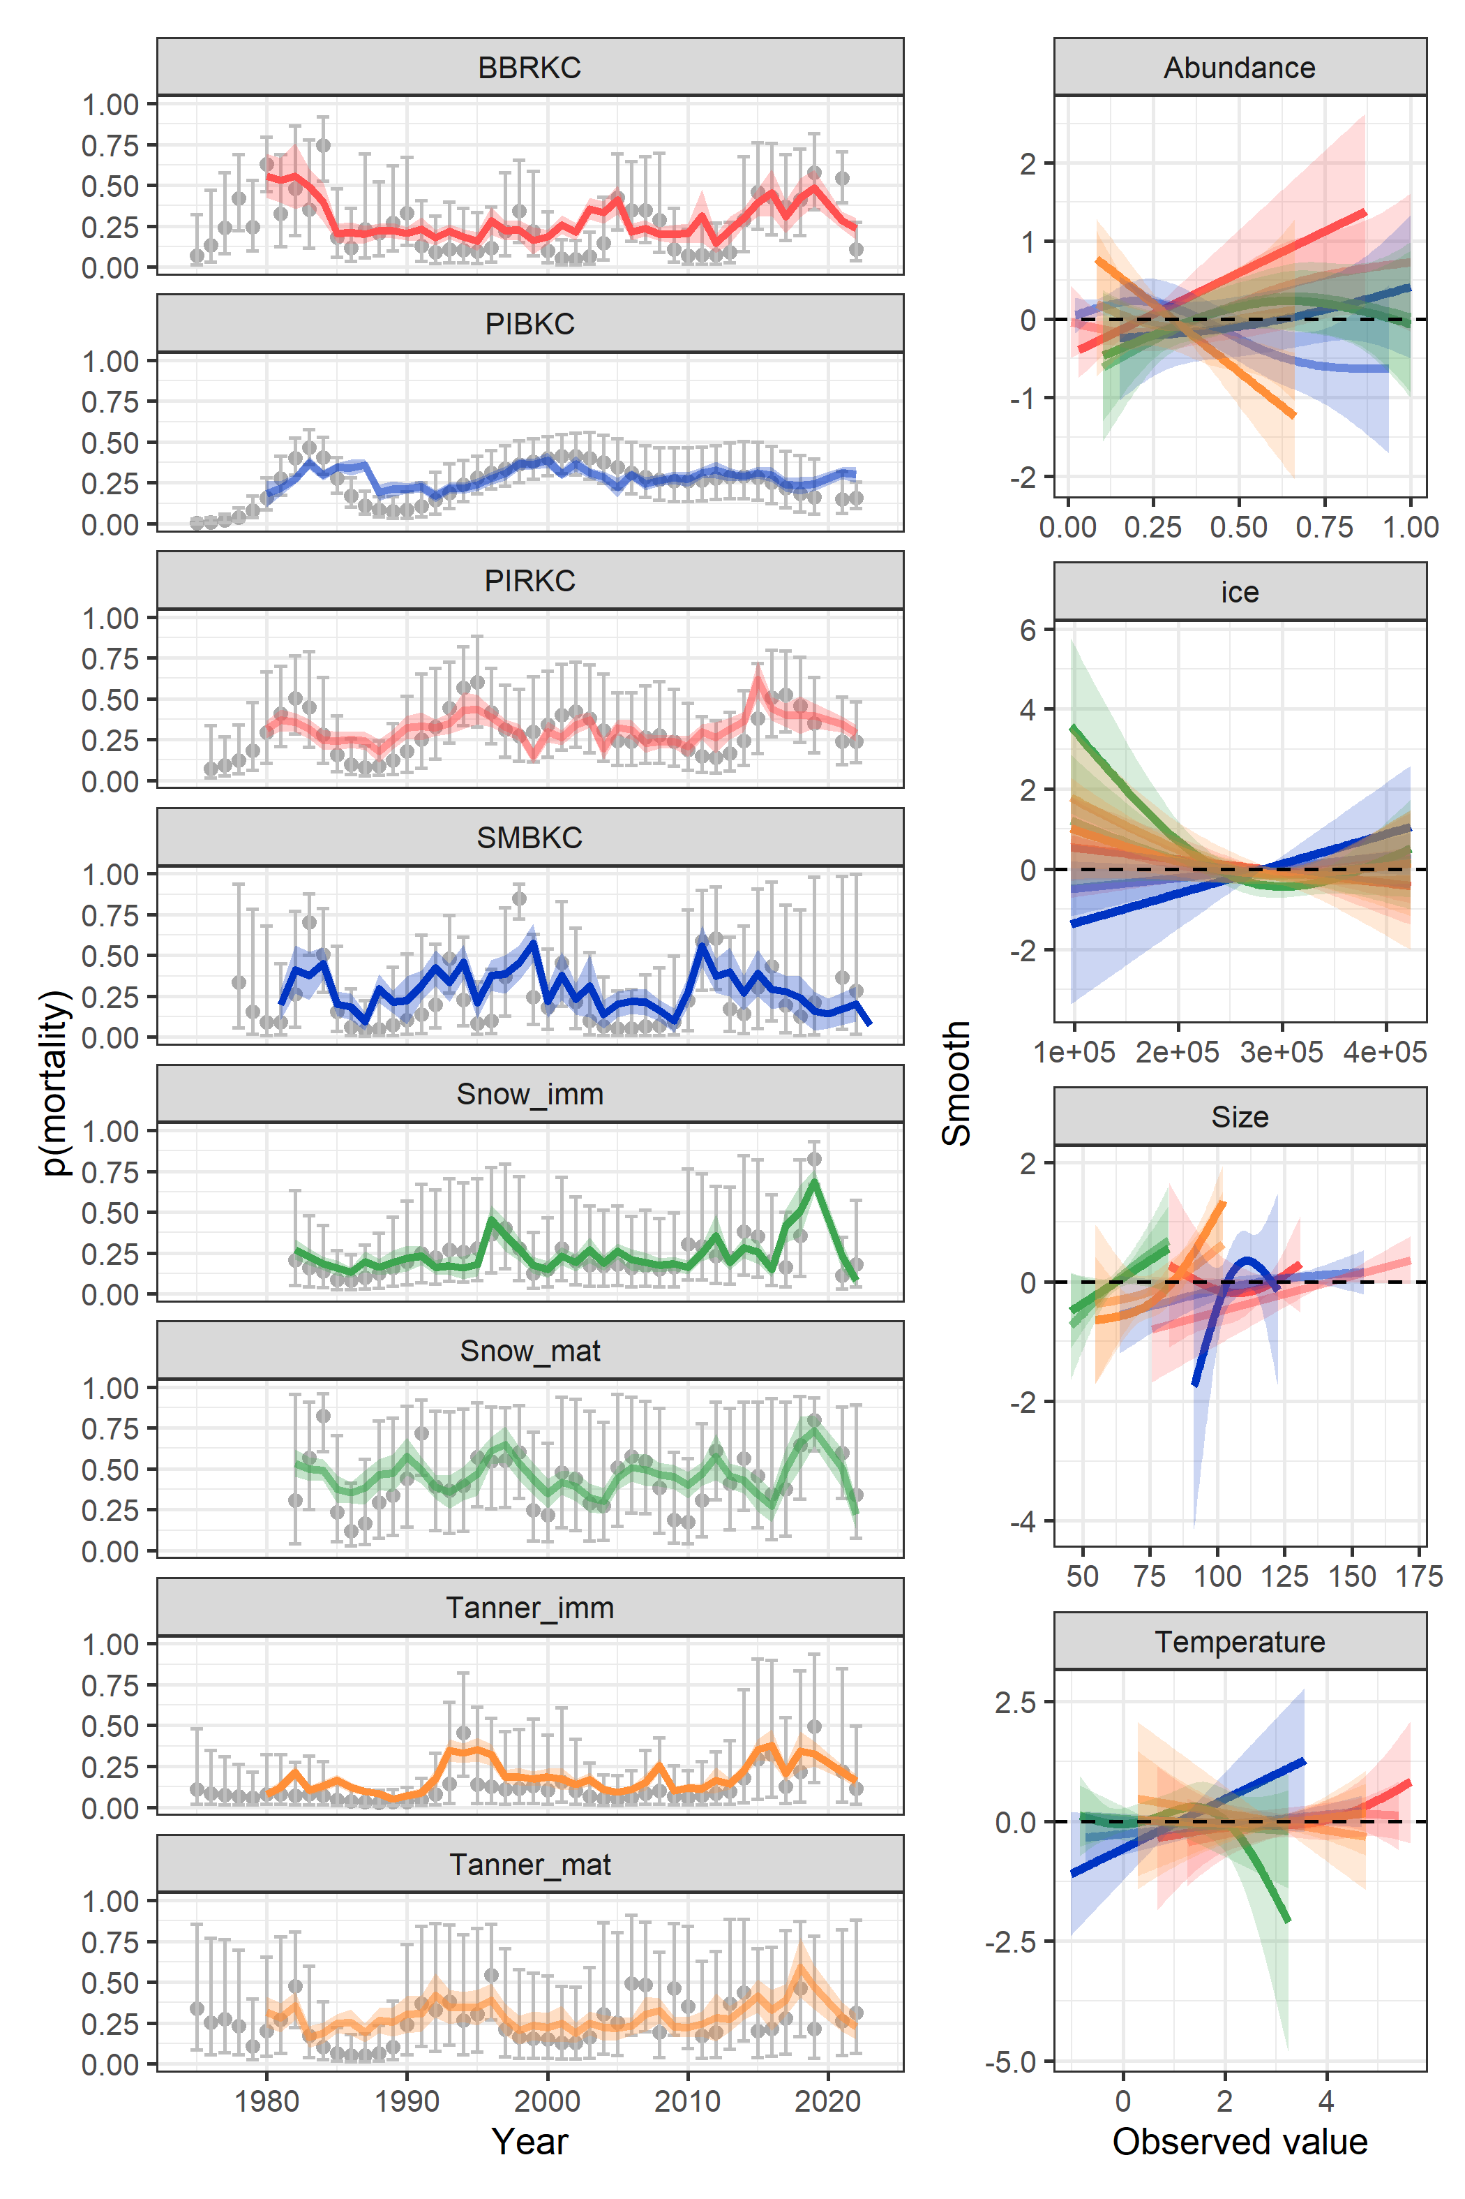
Figure 2. Estimated mortality from population dynamics models (left; grey dots with 95% CIs) with GAM estimates of those time series (colored lines with ribbons representing 95% CIs). Smooth relationships estimated within the GAMs for four covariates. Colors represent a population and are consistent among figures.

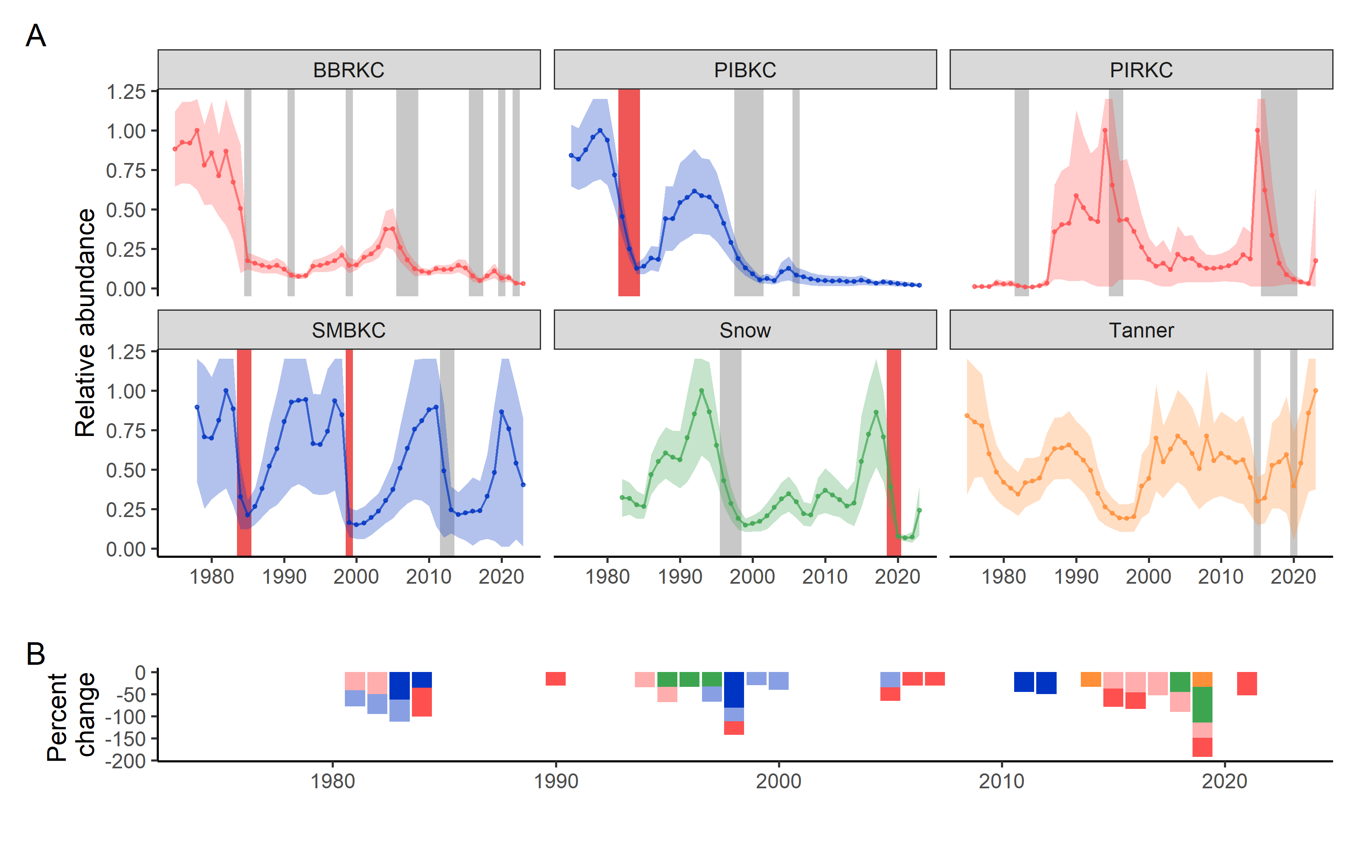
Figure 3. Estimated relative total abundance by crab population (A) with periods during which the abundance declined by at least 40% (vertical rectangles). Red rectangles correspond to periods of decline during which estimated fishing mortality was greater than the median; grey bars indicate periods when fishing mortality was below the median. Panel B collates the declines by year, magnitude, and stock.

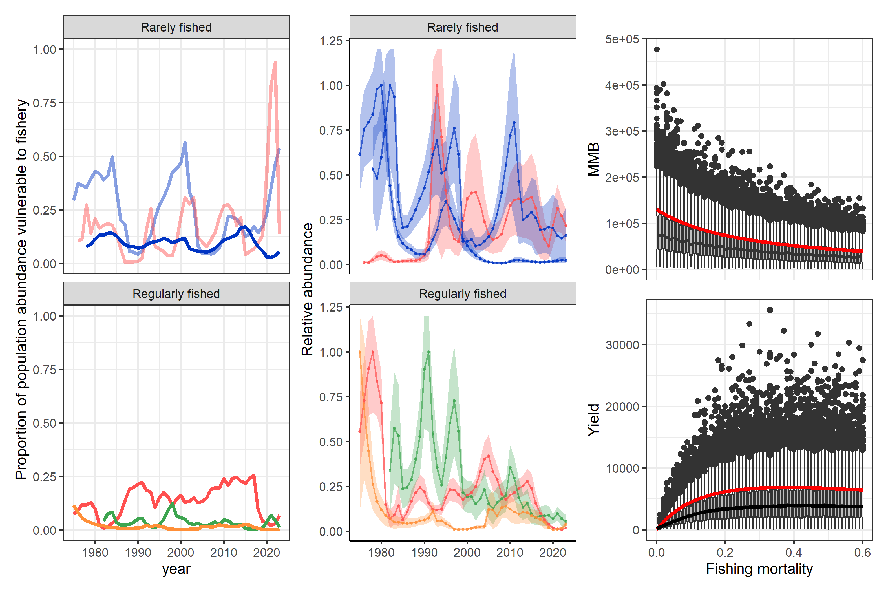
Figure 4. Proportion of population vulnerable to fishing for rarely fished and regularly fished stocks (left column). Trajectories of the abundance of crab vulnerable to fishing (middle column) from rarely fished populations and regularly fished populations (bottom right). Equilibrium mature male biomass and fishery yields (right column) for BBRKC under a given fishing mortality when other mortality is constant (red line) and when mortality events are considered via stochastic simulations (box plots).

